A QUICK, HANDY GUIDE TO HOME GARDENING
BY INDIAN GARDEN BLOG www.budscape.net
https://www.facebook.com/budscape/

JOIN OUR GARDENING COMMUNITY – GARDENING TIPS INDIA https://www.facebook.com/groups/1629966650655491/
(NOTE- CTRL+CLICK ON THE PICTURE TO READ THE ARTICLE ON THE WEBSITE)
BANANA PEEL FERTILIZER PAGE 3
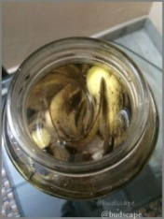
HOW TO GROW CARNATION PLANT FROM FLOWER STICKS PAGE 6

HOW TO SOW SEEDS - THE BEST AND EASIEST WAYS TO ENSURE GERMINATION PAGE 9
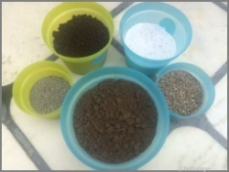
ECOBIN - BOKASHI COMPOSTING on the kitchen counter-top! PAGE 12
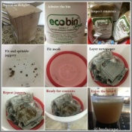
HOW TO GROW AND STORE CHAMOMILE FOR TEA - BENEFITS AND USES PAGE 14
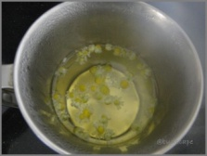
WATERING TIPS- HOW TO AND WHEN TO WATER PAGE 16
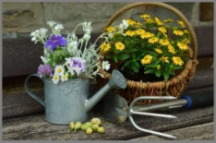
HOW TO GET RID OF MEALY BUGS IN HOUSEPLANTS PAGE 18
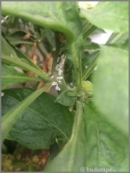
GROW WHEATGRASS AT HOME PAGE 21
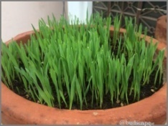
MAKE ALOE VERA GEL AT HOME – DIY PAGE 23
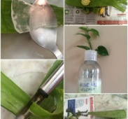

PLEASE SCROLL DOWN FOR ARTICLES

BANANA PEEL FERTILIZER
Do you find it easier to toss a banana peel into the bin than into the compost pile? Do you also feel guilty doing so? Fret not, there are some easy ways to curb the guilt of lazy gardeners.
Listed below are some fool-proof ways to make the best use of those banana peels to fertilize your garden naturally.(I feel the itch to make a "gone bananas" joke here but can't quite click it)
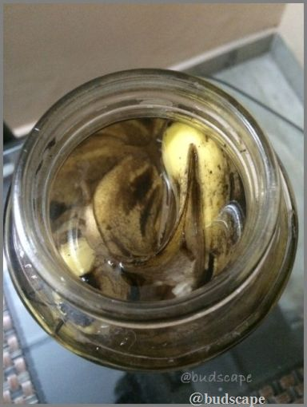
BANANA PEEL TEA
HOMEMADE BANANA PEEL FERTILIZER / FRUIT ENZYME SPRAY
METHOD #1 Take a large glass jar and throw in as many peels as you have. Top it up with water. Cover the jar with, either a lid having holes, or, a fabric and an elastic tie. Let it sit and ferment for 2-3 days. It will turn muddy, just how it is supposed to be. Filter the liquid and use in the pots directly or dilute to spray over foliage. Do not throw away the peels yet, compost them or bury directly in soil near the roots of some established plant.
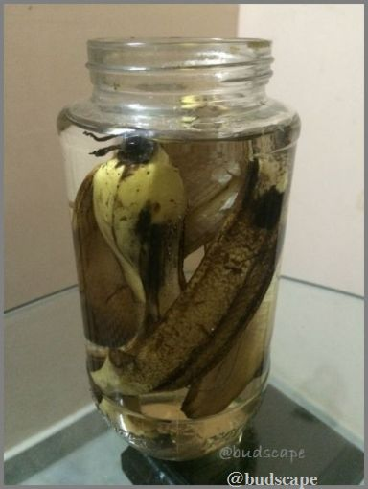
BANANA PEEL TEA
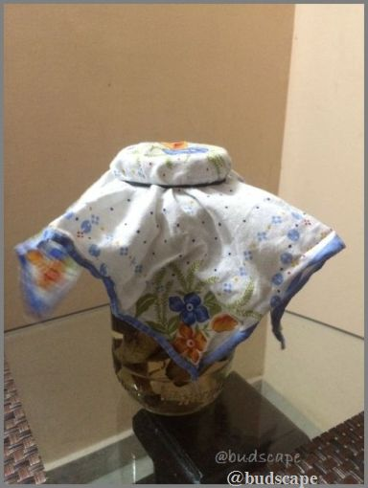
BANANA PEEL FERTILIZER
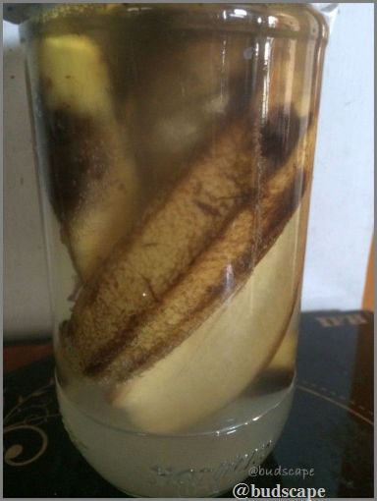
BANANA PEEL FERTILIZER
METHOD #2
Keep the banana peels in fridge till they dry out(usually 3-4 days). Then, CTRL+CLICK HERE TO READ THE FULL ARTICLE

HOW TO GROW CARNATION PLANT FROM FLOWER STICKS
Where i live, two plants always elude me - carnations and gerberas. The nurseries never get them and hence, i end to hoard them wherever i find them. While i am yet to find good seeds for gerbera, i am never satisfied with the carnations we get from seeds. This experiment is a result of my cravings for the big carnations often sold at florists. This post is in continuation to an earlier one wherein i'd tried to root a carnation flower stick into a plant. I am also extremely happy to announce that it has been a surprisingly successful attempt and my carnation plant is now happily growing, ready to bloom this season. I am documenting the complete process again for all those who have been trying to experiment with the same. I will also be listing a few pointers/observations at the end of this post, for those trying this for the first time.
Before this successful attempt, my annual visits to palampur were complete only if i could get my hands on the carnation plants. Now, i can just go to the florist and pick the colors i like to turn into plants :)
STEP 1
Buy some fresh and healthy carnation sticks, with straight green stems. If you are trying this from a bouquet you received, choose the freshest looking sticks.
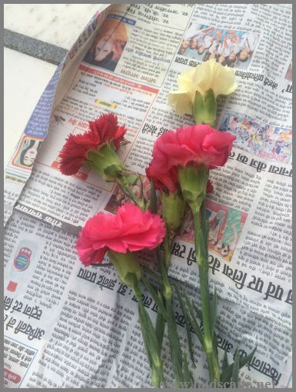
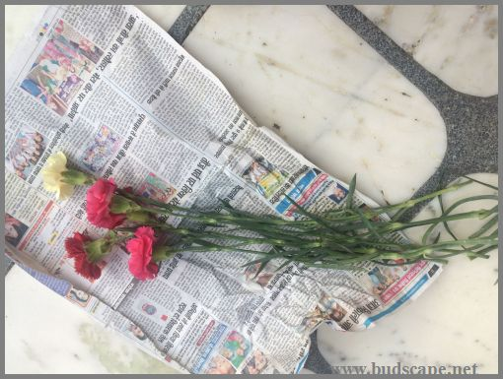
STEP 2
Cut the stems into smaller lengths with 2-3 nodes per stick. Nodes are important because that's where the roots as well as leaves sprout from. Cut each stem into sections keeping the cut just below the node.
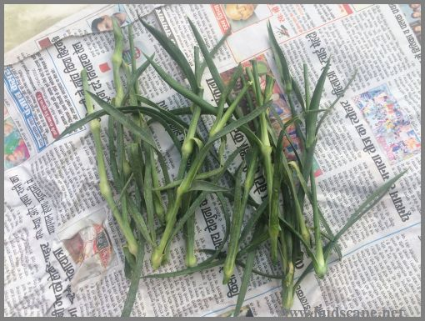
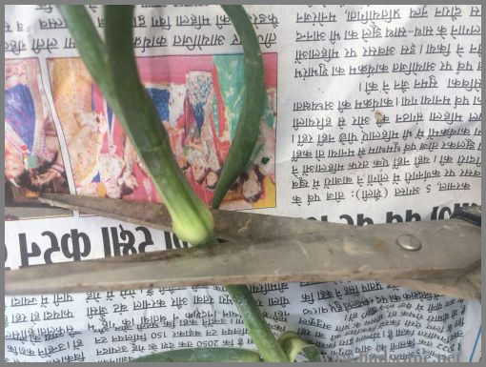
STEP 3
Remove all leaves above the last node.(This will go into the soil)
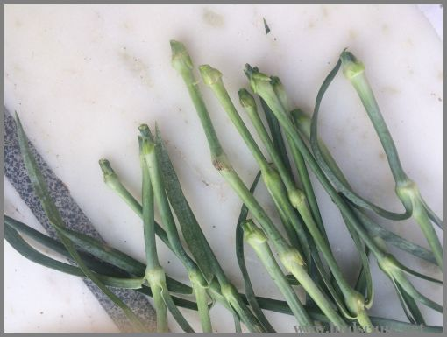

STEP 4
Prepare the soil. Mix 2/3 compost (or rich garden soil) with 1/3 sand in a pot. I used terracotta.
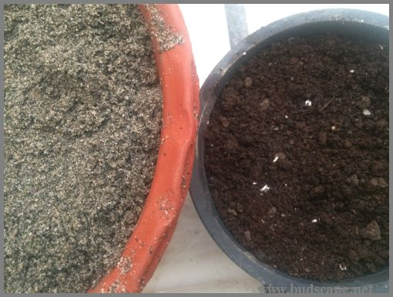
STEP 5
Wet the end of each stick and dip into rooting hormone. CTRL+CLICK HERE TO READ THE FULL ARTICLE

HOW TO SOW SEEDS - THE BEST AND EASIEST WAYS TO ENSURE GERMINATION
I love making lists. In-fact, i am ADDICTED. OCD. Borderline CRAZYYY; you get the drift.. I make lists about everything in my life, daily weekly, to-do, home, market, work, blog, fitness, cooking, travel; you name it, i have a list! I even have main lists and then sub-lists. ( you should try it, keeps your life sorted, mind de-cluttered and more focused.)I use the app NOTEBOOK. It's amazing!
So, it is given that as soon as winters knock on the door, i am up and about making numerous of lists of what to order, what to sow, how and where to sow, the planters to use, things to buy blah blah and blah. While i was doing that this season, it occurred to me that i have never posted about the most basic thing on my blog - SOWING SEEDS.
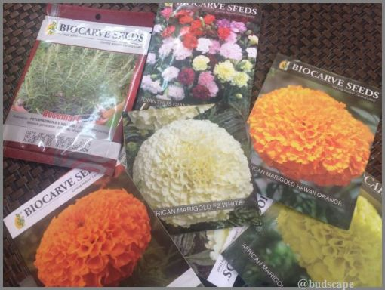
A packet of seeds thrills me like nothing else! Most newbie gardeners start with houseplants. I, bought lots of seeds and sowed them all in everything i could find. Surprisingly, most of them grew and bloomed. It was then that i discovered, this love affair will last a lifetime!
Subscribe in a reader
Seed sowing is an art! There are so many factors involved that it intimidates even the most experienced of gardeners. Growing from seed is also perhaps the most rewarding of all garden activities. The whole process of preparing the soil, sowing seeds, watering, germinating, transplanting and finally blooming is almost magical! Over years, i have played with almost all methods of sowing seeds and have finally discovered the best and easiest ways to go about it. Listed below are few of the "Best ways to successfully sow seeds" and some "Seed Sowing Tips". (in my humble opinion, of-course!)
Let's begin with the "IDEAL SEED SOWING MIX" (with a secret ingredient!)
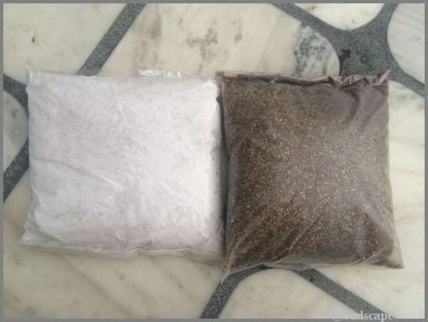
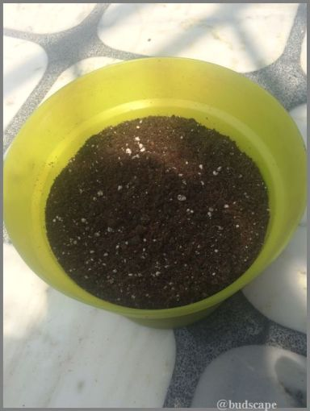
The best seed sowing mix includes:
BLACK GARDEN SOIL - Skip if you do not have good soil. Mine has been enriched over time so i use it.
COCOPEAT - For water retention and aeration of roots.
SAND - For drainage.
PERLITE - For aeration and to lighten the mixture.
COMPOST - For nutrition.
VERMICULITE - To cover the seeds and keep them moist. (You may do without it)
I BUY THESE INGREDIENTS FROM TECHNOCARE NURSERY, LUDHIANA.
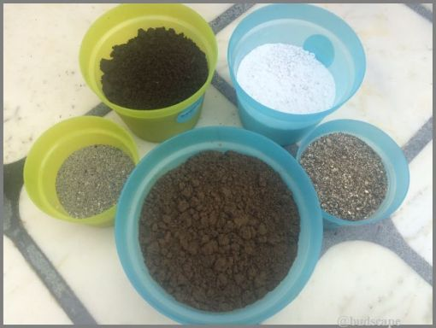
I mix the above (except vermiculite) in the following approximate ratio:
COMPOST- 40%
COCOPEAT - 20%
SAND - 20%
GARDEN SOIL - 10%
PERLITE - 10%
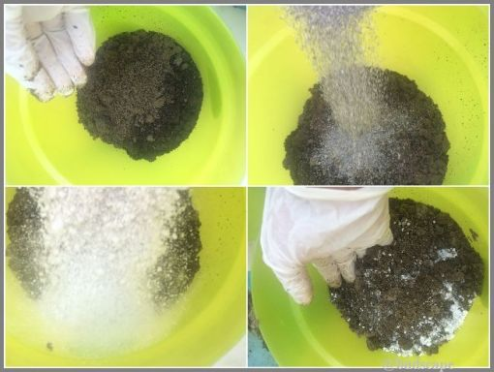
SECRET INGREDIENT FOR SEED SOWING MIX: CTRL+CLICK HERE TO READ THE FULL ARTICLE

ECOBIN - BOKASHI COMPOSTING on the kitchen counter-top!
The crazy gardener in me is always open to all sorts of crazy ideas.. staying up all night to divide a gerbera early morning, planting seeds in the wrong season to see if they sprout.. rarely going by the books.. trying to sprout cuttings with what-not.. u get it.. but never did i ever think of composting in my kitchen right on the counter top!!
LET'S EXPLORE THE BEST WAY TO COMPOST INDOORS , TOO!
Now composting and me have had a love-hate relationship. I love compost but i hate TO compost for all the stinky messy reasons. Being a DIY person by nature, i have tried making all sorts of composters myself with tubs n pots n matkis but living in a rented house now where fellow occupants do not take kindly to the smell and mosquitoes, i had almost given up till we move to our own place.
And then.. BOOM!! like a flash of lightening from the sky followed by a thunderous imaginary slap, realization set in and i wondered WHY haven't i tried the bokashi method i have been reading so much about!
To be honest i had brushed off assuming it to be another "posh" composting gimmick until i truly paid attention and what i discovered has presumably changed my life(or my garden)
Now, where i live,the soil isn't too good to begin with. And the endless bags of amendments i have dumped into pots did not really show their worth.
TBH the soil back in Punjab is RICH. You dig some garden soil, plant and wow..everything flowers!
(SEE SOME BEAUTIFUL FLOWERS HERE)
I don't know of it's the black rich soil from our garden but i never really needed much to make plants happy. Here, it takes effort.. and a lot of it!! I have a special formula that works for roses and certain flowering plants but when it comes to perennials, i am at a loss!!
So after a lot of studying, research and positive feedback, i decided to go the bokashi way.
There are a lot of tutorials on making your own bokashi bin, but i decided to play it safe and learn the ropes of the game first, and i do not regret it at all!!
WHAT IS BOKASHI?
Bokashi is a Japanese technique of anaerobic fermentation that includes picking of all the wet kitchen waste you dump into the bin, along with certain microbes (bokashi bran). So unlike traditional composting, you dump all the wet kitchen waste like peels, leftover food portions, wilted flowers and even some non-veg. Read all about it here. Sprinkle microbes and shut the lid tight.
Start collecting the liquid produced every 2-3 days and dilute it to spray/pour into your plants. Super easy, non-messy, non-smelly and quick!
Once the bin is full keep it shut and keep draining the liquid till it is produced; then dump exhausted contents into a pot with soil and starter compost to produce more compost super quickly!!
Meanwhile start filling the other bin and repeat.
So, many companies are selling the bins and i got myself a set of 2 10lt. bins from myecobin.in
I ordered the bin two weeks ago, received it last Friday, and today i have already collected more than 500ml of brew(LEACHATE) which means 500*50(water)=25000 ml of ready spray!!
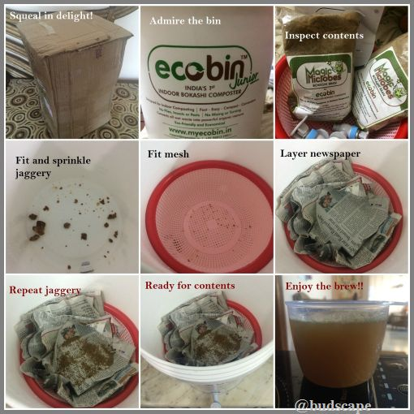
HOW TO USE ECOBIN FOR BOKASHI COMPOSTING
Since the efficiency of any garden amendment can only be vouched for when we see progress with naked eyes, i have take "before" pics of the most sorry and sad looking plants that just refuse to grow despite me trying every method in the book. CTRL+CLICK HERE TO READ THE FULL ARTICLE

HOW TO GROW AND STORE CHAMOMILE FOR TEA - BENEFITS AND USES
I love non-milk teas of all kinds.. On trips to hill stations, i love exploring the little shops that store boxes & bags of flavored teas, looking for something fruity and floral and fun. For the same reason, i love the brand FabIndia for their tea blends.. recently i picked up mango vanilla( to be honest i liked the sound of it) which i really liked though everyone around me hated it( my husband and my best friend whom i forced to drink)
So apart from green tea that everyone is supposed to love for health reasons, if there's one flavor close to my heart it's chamomile.. Though i really like the chamomile-honey blend from the shelves, nothing comes even close to a cup of fresh tea brewed from flowers from the garden.. I remember me and my dad having a cup each at midnight while being engrossed in our desktops.. ( i must admit that i get scared very easily yet i thought nothing of going at 1am to pluck some flowers from the garden)
Coming back, i had a few leftover seeds from the first batch(that my grandfather got me from Palampur)but they never germinated again.. so this year i picked up a fresh packet of German chamomile from Omaxe seeds which turned out to be a great pick.. Excellent germination and amazing flavor..
Apart from always being successful at putting me to sleep when i am struggling with insomnia, it has also helped with soothe an irritated stomach and inflamed skin.. no wonder it has become one of my favorite herbs..
The recipe(if anyone is interested) is simple and remains similar for multiple purposes..
Boil some water, switch off the flame, drop a few flowers and let them steep for a minute or so.. Strain and enjoy!!
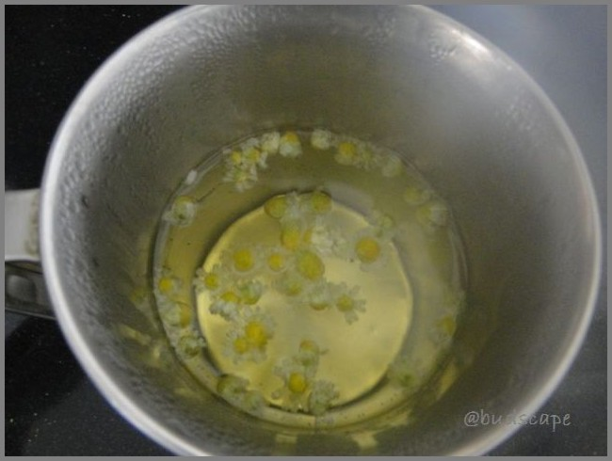
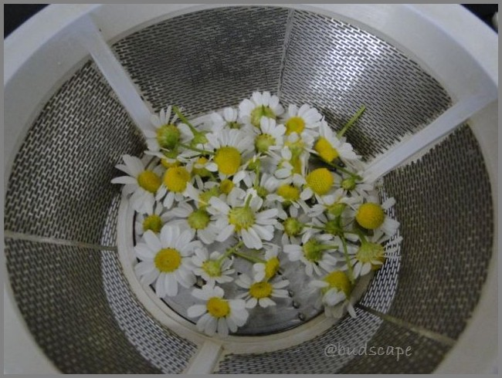
Since i like the natural sweetness i do not add honey but you can if you feel so.
For skin, boil the flowers with water and let steep for a few hours.. Add any complementing essential oil if you wish to and refrigerate in a spray bottle.
Since we first need to harvest and store the flowers for recipes above, here's what i did.. CTRL+CLICK HERE TO READ THE FULL ARTICLE

WATERING TIPS- HOW TO AND WHEN TO WATER
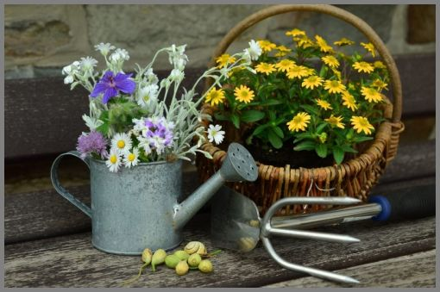
So, i went out for a stroll in the garden and realized the plants were scorched and limp from the sudden rise in temperature. It was past sunset and while i contemplated watering or not, it occurred to me how many new gardeners are confused about watering (I was there once!).
It may seem like the simplest garden task BUT contributes significantly to plant health. Hence, in the simplest language possible, here's a
NEWBIE's GUIDE TO CORRECTLY WATERING PLANTS
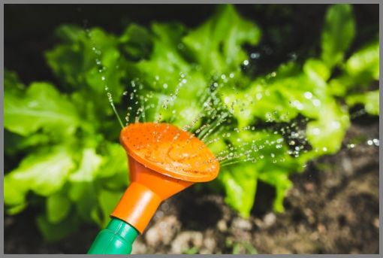
WHAT IS THE BEST TIME TO WATER PLANTS - MORNING OR EVENING?
This is the trickiest! The basic requirement is that the roots get ample time to soak up the water before it is evaporated by the sun. e.g. In summers water early in the morning so that the planters do not dry out immediately or in the evening after the glare has lessened.
In winters, watering in the morning is the best choice for reasons stated below.
P.S. I have been known to water mid-noon in the glaring sun out of desperation either when a plant seems almost dead or i am travelling. Not a good habit at all but works in an emergency ONLY.

HOW MUCH TO WATER PLANTS?
If the soil looks dry or the leaves appear wilted, water it! All plants have varying watering requirements. To fix a schedule, water a plant thoroughly once and note after how long does it demand water again.Do this for a few days to figure out its schedule. Group plants with similar timings together.
Generally planters require water once a day in summers and once every 2 days in winters with moderate sunshine. Rainy and cloudy days are obvious exceptions. Gardening does benefit from a bit of
common sense, isn't it?
If it leaves appear dry, crumbly or shrunk, the plant needs water.
If they appear yellowing and wilted, over-watering may be one of the causes.(Because it may also be a deficiency)
If you notice thinning or rotting at the base(specially annuals like gerbera), either you are watering too much or it isn't draining properly. Plants must never float or stand in water! (unless you are growing rice :P )
This applies to perennials-CTRL+CLICK HERE TO READ THE FULL ARTICLE

HOW TO GET RID OF MEALY BUGS IN HOUSEPLANTS
WHAT ARE MEALY BUGS?
Mealy bugs are small,white,squishy soft insects that stick to plant stems and suck the life out of them. Apart from being extremely unsightly, mealy bugs are also very rigid and spread quickly on a plant. Timely cure is very important as they can cover a plant within days and kill it, if ignored.
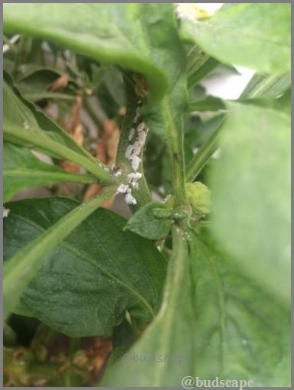
In a gardener's language, mealy bug is an icky, irritating, annoying little creature that stubbornly refuses to die or go away and manages to shoot up the B.P. of every gardener and kills the joy of summer gardening. If i could, personally, figure out where their tiny necks are, i'd wring the life out of them!
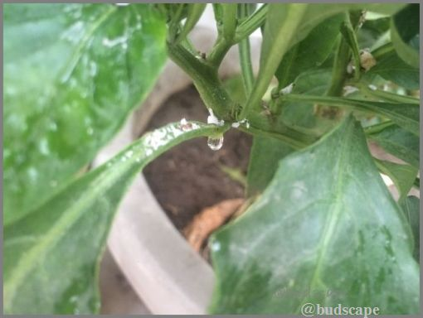
What plants are easily affected by mealy bugs?
They arrive with the summers and perch themselves on Hibiscus, Plumeria, Portulaca, Zinnia, Sunflowers, tomatoes, lady's fingers and peppers among others.
Mealy bugs usually affect the fresh growth, underside of leaves and top tips of a plant and hence are easy to treat before they spread down and take over the plant.
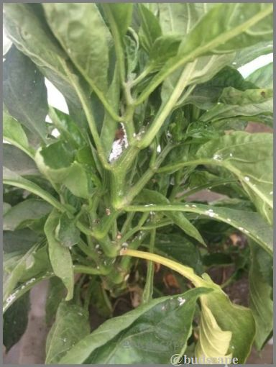
So, HOW TO GET RID OF MEALY BUGS ON HIBISCUS AND OTHER PLANTS?
This is a sure shot method that ALWAYS works for me.
First of all, aim a jet of water from a hose onto the bugs while holding the stem in place with one hand. Target all fresh growth, tips and underside of leaves. If the plant is in a container, tilt the pot onto the ground to get more access and coverage.
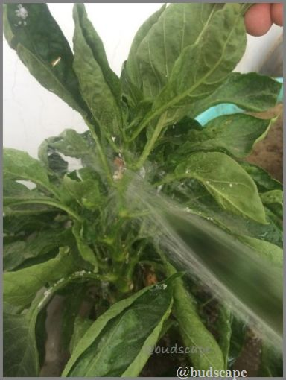
Remove as many bugs as you can, with a sharp spray of water.
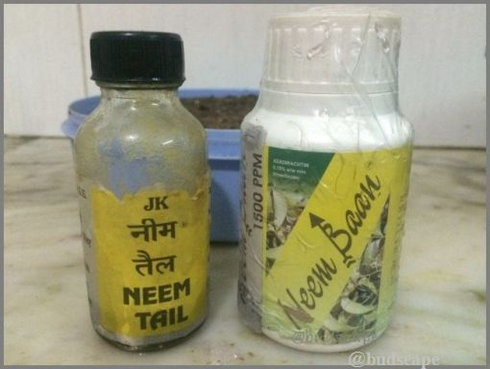
NEEM OIL , NEEM BAAN
Next, our weapon to fight mealy bugs is NEEM. Neem is a magical plant available in the form of powdered neem leaves, neem cake and neem oil for uses in the garden. CTRL+CLICK HERE TO READ THE FULL ARTICLE

GROW WHEATGRASS AT HOME
Wheatgrass needs no introduction, and rightly so! While there are many "health" foods gaining rapid popularity, most of them also die back quickly, without a trace! Wheatgrass, perhaps, is the only "wonder-food" that is even recommended by doctors to treat a ton of ailments.
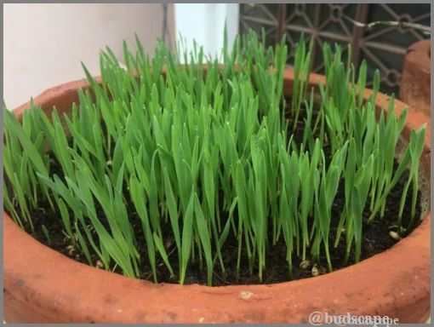
WHEATGRASS SEEDLINGS
WHAT IS WHEATGRASS?
To put it simply, wheatgrass is the name for 2-3 days old wheat seedlings, that appear grass-like. They are then harvested and juiced for consumption.
It has been named a super-food for all the right reasons as it contains all sorts of nutrients raging from all vitamins, minerals, amino acids and most importantly chlorophyll, which is an important component for building Red blood cells.
BENEFITS OF WHEATGRASS JUICE FOR HEALTH
In a nutshell, wheatgrass is known to heal the body from inside out and hence,is beneficial for acidity, arthritis, bad breath, detoxification, anemia, boosting immunity and general well-being.
Wheatgrass has also been extensively linked to healing cancer and the side-effects of chemotherapy. One reason for this belief is that, chemotherapy kills the good blood cells along with the bad ones, hence reducing immunity. Wheatgrass boosts the production of RBC's thereby providing strength and immunity to the body. It is also believe to kill cancer cells though this has not been scientifically verified, yet.
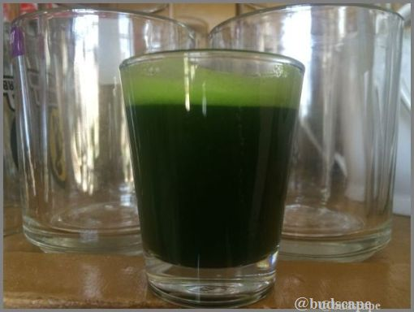
WHEATGRASS JUICE
HOW TO GROW AND CONSUME WHEATGRASS?
Just like any other fresh juice, it is recommended to consume wheatgrass, as fresh as possible, to reap the maximum benefits. It is also advised to take this juice first thing in the morning, while harvesting as soon as the sun rises. Hence, it is the best to grow your own supply at home, which is a quick and easy process.
STEP 1: GATHER ALL MATERIALS NEEDED
You will need:
a) A container to grow in. Anything wide and moderately shallow does the job. The good thing about growing wheatgrass is that there are no set rules for drainage. If your container has drainage, it's good; if it doesn't but is deep enough, that is good too. Also, you can have some additional drainage by adding a layer of gravel at the bottom. You can even poke a hole at the bottom of a some plastic container to use it for sowing the seeds. Hence, this is quite a flexible choice. CTRL+CLICK HERE TO READ THE FULL ARTICLE

MAKE ALOE VERA GEL AT HOME - DIY
Growing, sharing, preserving and cooking seem to be siblings to me.
As soon as i ventured out of my comfort zone of flowers into vegetables and herbs, the latter 3 seemed to be the next obvious option. As someone who hates wasting things, i am constantly looking for best ways to use what i grow in my garden. While, this has definitely added to my intelligence quotient (:P), it has also helped feed my skincare obsession( my second love) in the best possible manner. As summers arrive, the first thing i do is harvest some Aloe Vera leaves and whip up a batch of my tried and tested Aloe Vera gel.
Aloe Vera, known as ghritkumari, in Hindi, is almost a wonder plant. Even though i am confident of even a 3-yr old being able to list out it's benefits, i will repeat what i know, for those of you living under a rock:
- Soothes sunburn, reduces tan and gives you clear radiant skin
- Helps hydrate skin
- Soothes and itchy scalp and reduces dandruff
- Promotes hair growth
- Regular use gives silky, shiny, hydrated hair
If consumed,
- It boosts immunity
- Reduces inflammation
- Promotes healthy digestion
- Aids weight loss(combined with a sensible diet)
No wonder, a batch of this miracle always exists in my fridge. While i do not consume it regularly(it tastes bitter), i never forget to apply the gel-ish liquid on my skin and hair.
Making it is easy, quick and simple.
- Harvest some fleshy leaves and keep them in a container for 15-20 mins to drain out the
yellow liquid.
- Wash the leaves and cut off a little from the top and bottom.
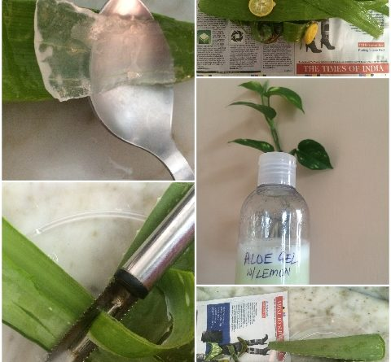
- Take a peeler and remove the thorns.
- Peel off the skin from the flat side. It is extremely easy to do this with a vegetable
peeler. CTRL+CLICK HERE TO READ THE FULL ARTICLE

FOR MORE SUCH TIPS, TRICKS, DIY’s & COMPETITIONS, VISIT www.budscape.net
https://www.facebook.com/budscape/

JOIN OUR GARDENING COMMUNITY – GARDENING TIPS INDIA https://www.facebook.com/groups/1629966650655491/

